#include <stdio.h>

typedef struct

{

    char ename[20];

    int eage;

    char designation[20];

    char address[50];

} employee;

int main()

{

    int n, i, nage, q = 0;

    char filename[24], t;

    FILE \*fp;

    char ename[20], address[20], designation[20];

    int eage, p, s;

    employee \*e;

    printf("Enter the number of employee records:\n");

    scanf("%d", &n);

    e = (employee \*)malloc(n\*sizeof(employee));

    printf("Enter the employee details:\n");

    for (i = 0; i < n; i++)

    {

        printf("Enter the filename to create: ");

        scanf("%s", filename);

        fp = fopen(filename, "w");

        printf("File created: %s\n", filename);

        printf("Enter employee name :");

        scanf("%s", e[i].ename);

        printf("Enter employee age :");

        scanf("%d", &e[i].eage);

        printf("Enter employee designation: ");

        scanf("%s", e[i].designation);

        fprintf(fp, "%s %d %s", e[i].ename, e[i].eage, e[i].designation);

        printf("Contents written to file successfully.....\n");

        printf("-----------------------------------\n");

        fclose(fp);

    }

    do

    {

        printf("Enter your choice\n");

        printf("1. Enter employee details and display\n");

        printf("2. Edit eage and display the updated content\n");

        printf("3. Append address to a file & display appended content on screen\n");

        scanf("%d", &s);

        switch (s)

        {

            case 1:

            {

                printf("\nEnter filename to read contents: ");

                scanf("%s", filename);

                fp = fopen(filename, "r");

                if (fp == NULL)

                {

                    printf("Sorry filename does not exits...\n");

                    goto p;

                }

                printf("Employee details is as follows:\n");

                if (q == 0)

                {

                    fscanf(fp, "%s %d %s", ename, &eage, designation);

                    printf("Name:=%s  Age:=%d  Designation:=%s\n", ename, eage, designation);

                }

                else

                {

                    fscanf(fp, "%s %d %s %s", ename, &eage, designation, address);

                    printf("Name:=%s  Age:=%d  Designation:=%s  Address:=%s\n", ename, eage, designation, address);

                }

                fclose(fp);

                printf("------------------------------------\n");

                break;

            }

            case 2:

            {

                printf("Enter filename to update age: ");

                scanf("%s", filename);

                fp = fopen(filename, "r");

                fscanf(fp, "%s %d", ename, &eage);

                printf("Enter new age: ");

                scanf("%d", &nage);

                eage = nage;

                fclose(fp);

                fp = fopen(filename, "w");

                fprintf(fp, "%s %d", ename, eage);

                printf("Content updated to file successfully.....\n");

                fclose(fp);

                printf("------------------------------------\n");

                break;

            }

            case 3:

            {

                printf("Enter filename to append address: ");

                scanf("%s", filename);

                fp = fopen(filename, "a");

                printf("Enter address to append to the file: ");

                scanf("%s", address);

                fprintf(fp, " %s", address);

                printf("Address appended to file successfully.........\n");

                q++;

                fclose(fp);

                break;

            }

        }

    p: fflush(stdin);

        printf("----------------------------\n");

        printf("Enter y to continue or n to quit\n");

        scanf("%c", &t);

    } while (t != 'n');

    return 0;

}

Output

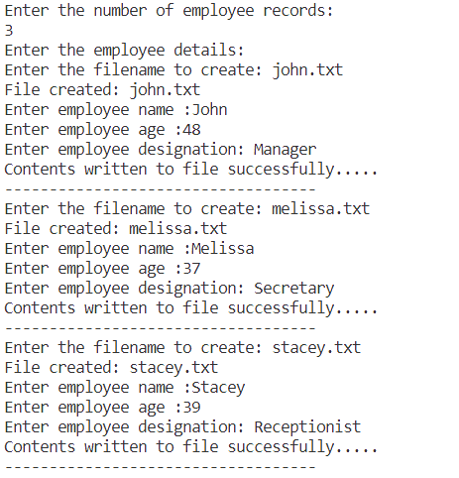

Editing the eage of a file

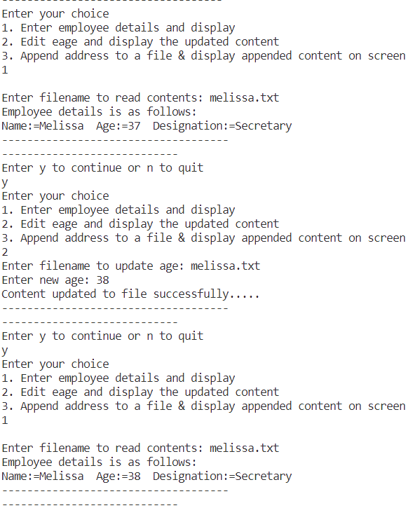

Appending address to a file

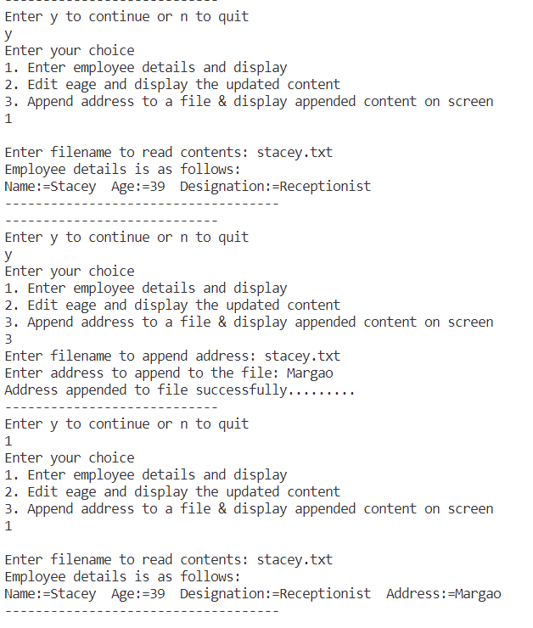

File contents

